**DEEP CONVOLUTION NEURAL NETWORK FOR BIG DATA MEDICAL IMAGE CLASSIFICATION**

**Objective:** The objective of this project is about classifying the various medical images for various body organs. This method of image classiﬁcation is beneﬁcial to predict the appropriate class or category of unknown images. As, Digital images play a vigorous role in predicting the patient disease intensity and there are vast applications of medical images in diagnosis and investigation.

**Software & Hardware Requirements:**

# **H/W Configuration:**

# Processor : I3/Intel Processor

* Hard Disk : 160GB
* RAM : 8Gb

**S/W Configuration:**

* Operating System : Windows 7/8/10 .
* Server side Script : HTML, CSS & JS.
* IDE : Pycharm.
* Libraries Used : Numpy, IO, OS, Flask, keras.
* Technology : Python 3.6+.

**Project Flow:**

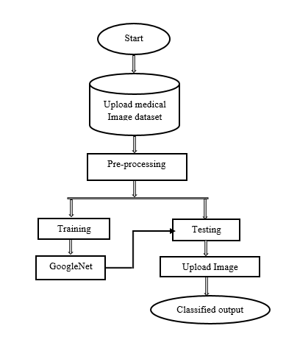

**Flow of Proposed Method**